**Batch:B2**

**Roll Number: 16010420061 Experiment No:3**

**Name:Sargundeep Sachdeo**

**Title of the Experiment:Data Pre-processing**

**Program:**

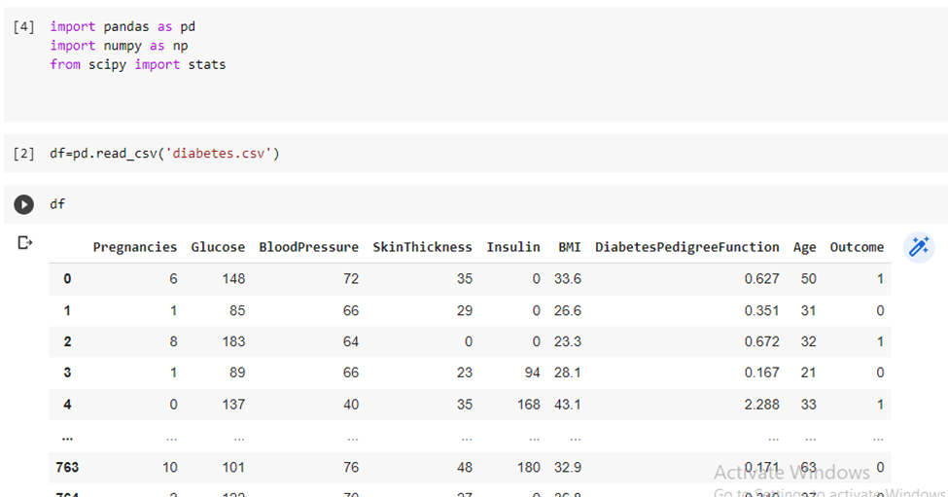

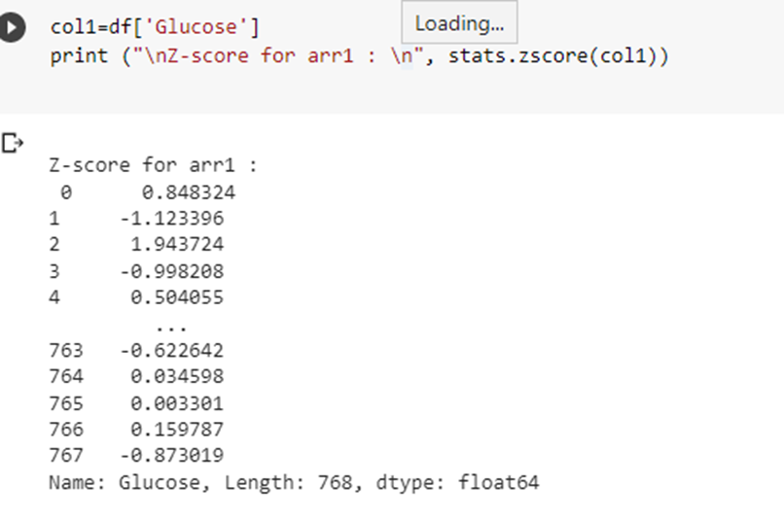

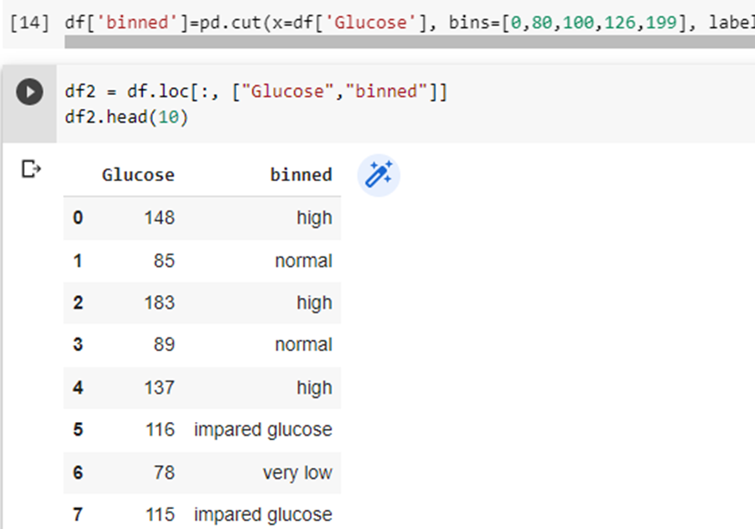

**Post Lab Question- Answers (If Any):**

**Q: Explain with example Min-Max normalization technique.**

**Ans:**Min-max normalization is one of the most common ways to normalize data. For every feature, the minimum value of that feature gets transformed into a 0, the maximum value gets transformed into a 1, and every other value gets transformed into a decimal between 0 and 1.For example, if the minimum value of a feature was 20, and the maximum value was 40, then 30 would be transformed to about 0.5 since it is halfway between 20 and 40. The formula is as follows:

**\frac{value - min}{max - min}**

Min-max normalization has one fairly significant downside: it does not handle outliers very well. For example, if you have 99 values between 0 and 40, and one value is 100, then the 99 values will all be transformed to a value between 0 and 0.4. That data is just as squished as before! Take a look at the image below to see an example of this.

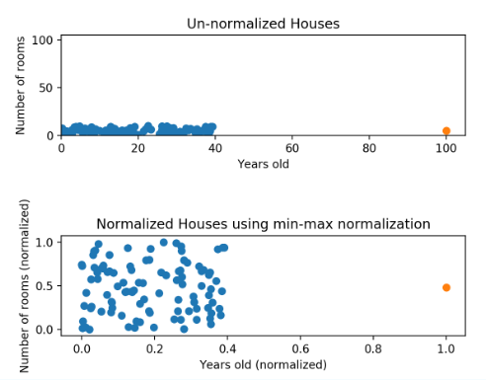

Normalizing fixed the squishing problem on the y-axis, but the x-axis is still problematic. Now if we were to compare these points, the y-axis would dominate; the y-axis can differ by 1, but the x-axis can only differ by 0.4.

**CO:** Comprehend basics of ML

**Conclusion:** In this experiment, I successfully understood and implemented Data preprocessing techniques.